Ghost Spelling
This fun spelling activity truly is magical! Students need a white crayon to write their words. After he/she writes the word, rub a marker over top of the white crayon to reveal the ghost spelling word. Be ready to hear the oooh’s and ahhhh’s!

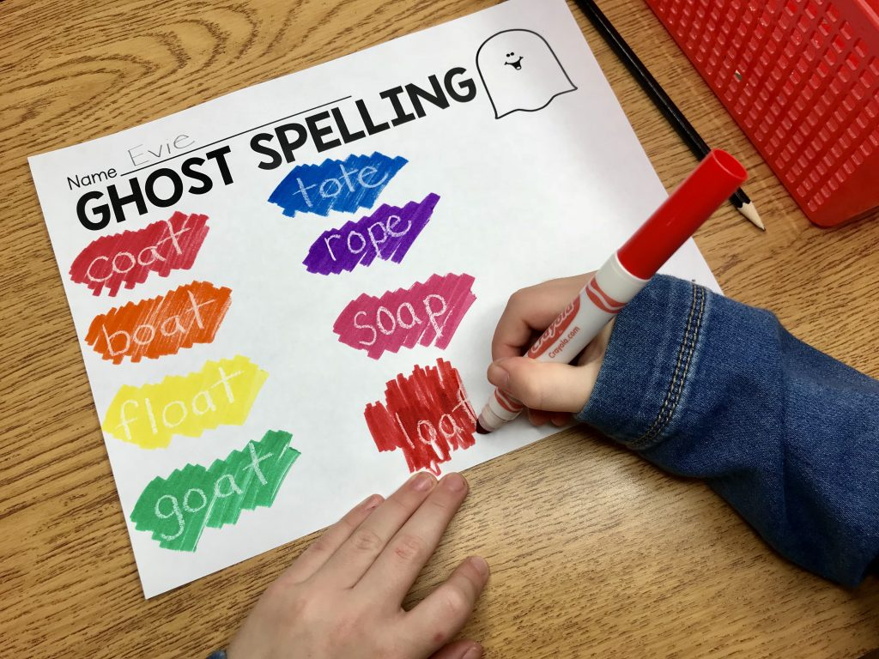
Box Spelling
Box spelling serves a couple of intentional purposes. Not only are the students practicing how to spell the words but also are revisiting the formation of the letters!
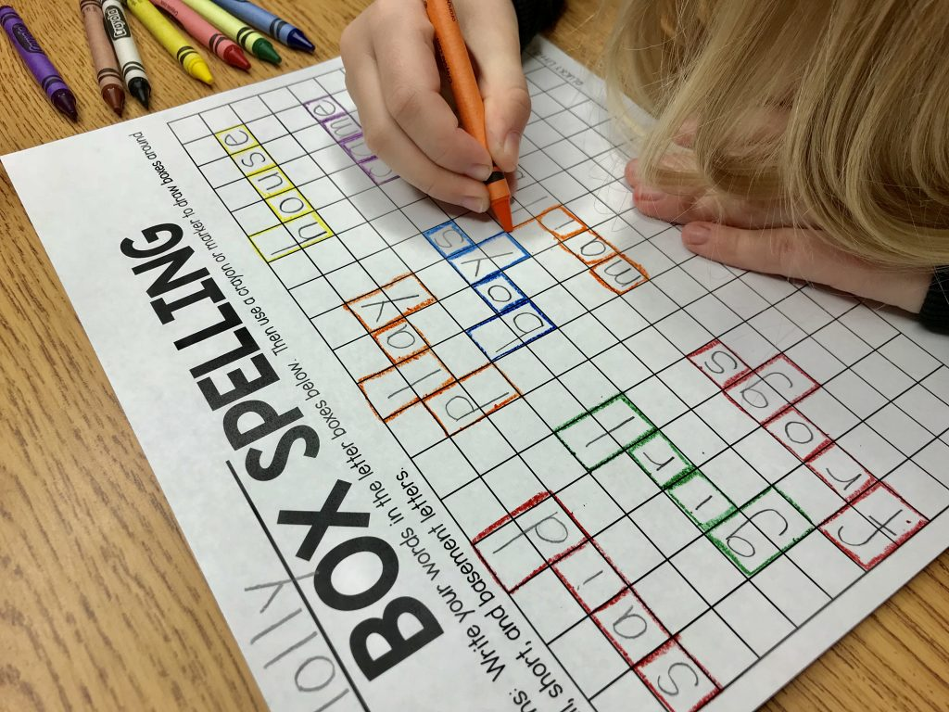

Type and Spell
Give students a pretend keyboard and watch their eyes light up with excitement as they pretend to type their words! So fun!
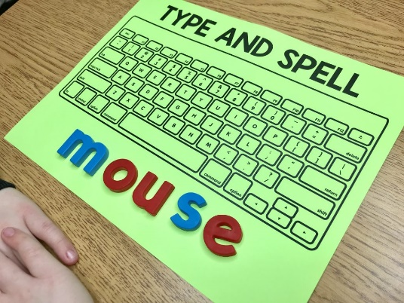

Study the Word
Study the Word is another activity that has several purposes. Besides the obvious spelling practice, it also provides an opportunity for the students to practice their vowels, consonants, and syllables.
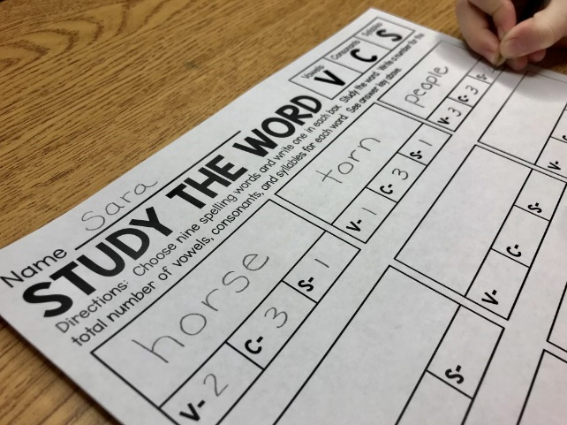
Crack the Code
Calling all detectives! Students love Crack the Code! Students create a “code” on the right side of the sheet. When finished, they find a partner to exchange papers with and they solve each other’s codes by figuring out the spelling word for each line and writing it on the right side. The paper gets folded.


